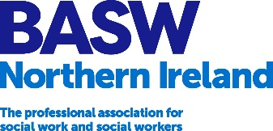
NATIONAL STANDING COMMITTEE / NORTHERN IRELAND COMMITTEE APPLICATION FORM
About you:

Name:

BASW Membership No. (if known):

Job Title:

Employer:
(if employed)

University:
(if applicable)

Date of Qualification:

Contact Details:

Address

Postcode

Email

Telephone

Areas of Interest/Practice:
Please tell us about your areas of interest or practice

Experience/Knowledge and Skills:
Please provide no more than 500 words about your experience, knowledge and skills.

Conflict of interest:
Please declare if there is any conflict of interest (commercially or otherwise) in your applying for this post.

Have you ever been involved or are you currently involved in a regulatory body conduct hearing?
Yes No

Have you ever been sanctioned, suspended or barred from practising social work?
Yes No

Have you been convicted for any criminal offences?
Yes No

I give consent for my statement of application and my photograph to be included in NSC election nomination marketing material, should an election be required.
Yes No

Declaration: I hereby declare that I am eligible for election and will abide by the BASW Code of Ethics for Social Work, BASW Memorandum of Articles and National Standing Committee Terms of Reference.

Signature: ………………………………………………………………………....

Date …………………………………………………………………………

Please complete and return by 12pm on 22 September 2022 to n.ireland@basw.co.uk

